Soil is a Filter

Objectives:
- Students will discover that soils physically and chemically filter impurities out of water.
- Students will discover the role of soil in having good drinking water.

Introduction:
Asking questions is a good way to find answers (and to learn something).
- What is a filter? (Show a coffee filter or a tea bag to aid discussion.)
- Can soil be a filter?
- Do all soils work the same?

Hypothesis:
Briefly explain experiment.
- Have students make hypothesis and complete table.
- What will happen to the dirty water "floaties"?
- What color will come out the bottom?

Materials and Preparation:
- 3 oz and 5 oz solo cups (Put 3-5 holes in bottom of 5 oz cup. A toothpick works well.). The 5 oz cup fits inside 3 oz cup, the put the toothpick inside, between the cups.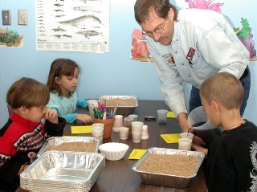
- play sand
- fine soil
- grape Kool-aid
- other colors, e.g., green, red, orange, yellow food coloring
- "floaties"

The results are more dramatic if the play sand has been sieved to remove the smaller particles. If you do not have soil sieves, you can use a colander or a spaghetti strainer if the holes are small. Another material that makes a good sieve is screening. A fine screen attached to a small frame makes an excellent sieve.

Methods:
We will use two soils, a sand by itself, and a sand with topsoil on top. (The sand keeps the topsoil in the cup.) Sand has large, rough particles. Topsoil is a mixture of particle sizes.

Sand
 | 1 | Take a 5 oz cup with holes in the bottom and fill it half full of sand.
 | 2 | Put it inside the 3 oz cup. Put a toothpick between the cups so that air can escape from the bottom cup.
 | 3 | Pour some of the dirty water into the top cup

Observe: | What happens to the things floating in the water?
Record: | Write your observations in the table.

 | 1 | Pour out the water in the bottom cup.
 | 2 | Pour some of the grape Kool-aid into the top cup.

Observe: | What color is the Kool-aid that goes into the cup?  What color is the water that collects in the bottom cup?
Record: | Write your observations in the table.

Topsoil
1 | Put a layer of sand the width of your pointer finger in the bottom of the 5 oz cup. (It has holes in it.)
2 | Add topsoil until the cup is half full.
3 | Put the 5 oz cup into the 3 oz cup.
4 | Pour some of the grape Kool-aid into the top cup.

Observe: | What color is the Kool-aid that goes into the cup?  What color is the water that collects in the bottom cup?
Record: | Write your observations in the table.
Compare: | Is the water in the bottom cup the same color for both soils?
Record: | Write your observations in the table.

- The photo shows the results of a filtering exercise.
- The upside-down cup on the left shows the holes in the bottom.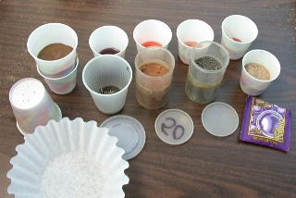
- To the right of that is a cup with soil inside the smaller cup. The toothpick is barely visible between the cups on the right side.
- The next four cups across the top contain the leachate (the water that ran through the soil) for the soils in the containers below them.
- The soils vary in color from gray to red to brown to the light brown sand on the right.
- The color of the water in the bottom cup ranges from purple (about the same color as the grape drink began), to bright pink,, to almost colorless, to a murky red.
- The coffee filter is given to the students to take home to remind them that soil is a filter.
- Discussion points: Remember that blue and red make purple. The smallest soil particles (clays) have a negative charge. Opposite charges attract and like charges repel. In all cases the red dye passes through the soil, so it must have a like charge as the soil (negative). The blue dye is retained in three of the soils, so it must have an opposite charge (positive). In this case, the soil with the purple leachate had very good structure, and the Kool-aid probably went through the pores and did not mix much with the soil.

So what? (Application)
- Soil naturally filters water that falls as rain and goes into rivers.
- Soil filters many chemicals out of water just like it did the grape Kool-aid.
- These same techniques are used to purify waste water that comes from houses, cities, industry, and large animal feeding operations.

A healthy soil is important for good drinking water.
Try this at home! Use different colors of water (green, red, orange, or others) using other Kool-aid flavors or food coloring.

